Vpn Explained and Implemented

Name
Institution of Affiliation
Professor
Date

VPN Explained and Implemented
A VPN short form of virtual private network is a form of protection of systems by providing a service that encrypts internet traffic thereby protecting one's online identity. Through this service, any searches or transactions done online are anonymised. A VPN works a tool to redirect a person's connection to the internet employing a remote server managed by a VPN provider. Thus, the server turns out to be the secure launching pad and tunnel for accessing various websites. In a typical scenario, a person trying to gain access to an internet website first one must connect to their internet service provider (ISP). The ISP then redirects the user to the website or online source he or she seeks. This means that all online traffic can be accessed to or logged on as it passes through the user's ISP server. A VPN will intercept the ISP server by rerouting the internet traffic to an encrypted server. This means only the user has control of the internet traffic and if intercepted by any other person, cannot be deciphered as it appears gibberish (Namecheap, n.d.). Therefore, no browsing history or metadata is collected and hence cannot be shared.
There are many service providers of this type of network which should not be confused with the technologies used by the service providers. VPN thus describes the service and not the technology provider though it has been incorporated as part of many service providers' names. Some VPNs are free while others are serviced at a fee each with their own protocols and limitations. However, most are offered at a premium and vary with purpose from personal to business use (Greenberg, 2020). The use of VPN has been gradually increasing as the use and the risk of private information being used or accessed by third parties increasing exponentially. Additionally, a VPN makes IP addresses appear to be as if it is in a different location from where the user is located. This allows one access to sites that may be restricted by ISP by connecting to numerous remote servers. Persons, who use public Wi-Fi or travel often, want to safeguard their browsing history from third parties, use file-sharing services, avoid government surveillance and/or are a journalist or political activist should strongly consider obtaining and using the VPN technology (NordVPN, n.d.).
Categories of VPN
For most corporates, it is vital to have a VPN since corporate espionage has rendered many firms bankrupt or non-operational. The main two categories of VPN are site-to-site VPN and remote access VPN (Vpnoneclick.com, n.d.). Remote-access VPNs are common to personal users to establish a protected remote server useful for accessing a private network which sometimes is combined with an added encryption. Site-to-site VPNs are mostly exploited in the corporate sector which may be intranet-based or extranet-based. The site-to-site VPNs enhance access of information by numerous users in several set locations. The intranet-based site-to-site VPNs ensure LAN(local area networks) in different locations are linked to one wide area network– thus securely sharing resources and information between each other. In contrast, extranet-based site-to-site VPN establishes a link amongst distinct intranets without the leeway of one gaining access to the other directly. Widespread use of Site-to-site VPNs is experienced in international corporate environments where secure communication between worldwide departments is vital.
Site-to-site VPNs are difficult to implement, since specialized equipment and amass resources are required as the technology is built with a purpose and no flexibility as in commercial VPN services. Router-to-Router communication is occasionally used to refer to site-to-site VPN. Often the two categories are disregarded and VPNs are classified according to the protocols used in the VPN. The common protocols include IPSec or Internet Protocol Security, Secure Shell (SSH), Point – to – Point Tunneling Protocol, Secure Sockets Layer (SSL) and Transport Layer Security (TLS) and Layer 2 Tunneling Protocol (L2TP). OpenVPN, Hybrid VPN and MPLS - (Multiprotocol Label Switching) VPN are also included as part of the list. These protocols are either used by the remote access and/or site-to-site VPNs. The main focus will be IPSEC, PPTP, Open VPN and L2TP.
IPSec is employed within an Internet Protocol (IP) network to keep internet use and browsing safe. IPSec safeguards IP interaction by validating the phase after which IPSec encrypts every data packet for the entire period of the online connectivity (VPNCop, 2018). IPSec functions in two modes, Tunneling and Transport modes, to watch over data transmission involving two dissimilar systems. The transport mode encodes meaning included in the communication in a data packet thereafter the tunnelling mode scrambles various messages contained in the entire data packet. Internet Protocol Security may be managed together with supplementary security protocols to boost the privacy of the network system. This VPN setup process takes time to deliver information, and it is pricey compared to some existing VPNs available in the market hence for users who want non- straightforward VPNs.
OpenVPN uses either User Datagram Protocol or Transmission Control Protocol to ensure the user has safe, secure and anonymous internet connectivity. This makes this VPN highly configurable but not originally supported on any widely held device platforms. OpenVPN is therefore readily available to users through third-party software. This is the most used VPN by commercial service providers since it is open-source, fairly secure with 256-bit encryption and can be customized easily. Since OpenVPN can be set up on any port, it is made available to almost all platforms hence easily circumvents firewall blockades. For this reason, restrictive nations, for example, China have hurdles jamming OpenVPN manageably without exposing businesses. According to Ostif.org, (2017), OpenVPN is considered the most secure VPN which is only vulnerable to some Denial of Service (DoS) attacks which has been plugged and fixed in the latest version of OpenVPN.
Point-to-Point Tunneling Protocol (PPTP) VPN generates remote tunnels to permit any internet traffic securely to construct protected internet connection. PPTP VPN is impeccable for either a home or a business user since it is very cheap. No additional hardware is needed nor does it require installing any features hence it being described as a comfortable VPN. Another advantage is that PPTP can be configured on Mac, Windows, and Linux systems. However, PPTP VPN presents no encryption facility, and hence this VPN rests on Point-to-Point Protocol (PPP) to offer the essential security attributes to its users (Pixel Privacy, n.d.).
Layer 2 Tunneling Protocol (L2TP) was technologically advanced through combined efforts between Cisco and Microsoft. L2TP is also referred to as Internet Key Exchange version 2 (IKEv2) (VPNCop, 2018; Pixel Privacy, n.d.). Unlike other VPNs, L2TP is not a solitary VPN but works hand in hand with one more VPN. The IKEv2 protocol is popularly combined with IPsec protocol to offer superior quality service giving the ultimate security. Data travels via a tunnel connecting two or more L2TP connection contacts and if IPSec is also used, IPSec then encrypts the data. IKEv2 does not scramble data if it operates on its own and it is reliant on PPP protocol similar to the PPTP VPN. IKEv2 is well-thought-out to be typically secure, easy to use and set up. L2TP is commonly stocked and frequently quicker than OpenVPN. Nevertheless, the need to use a second VPN for authentication with the possibility of incorrect implementation and accessed by NSA makes it disadvantageous.
Secure Sockets Layer and Transport Layer Security (SSL & TLS) have been recently combined to form a VPN protocol. These two are perfect for businesses that handle any e-commerce website or site to offer a variety of services to its customers and not home users. Hybrid and MPLS VPN describe VPNs that work simultaneously to achieve anonymity. Hybrid and MPLS VPN may be as a result of altering the work of either one or more VPNs used together. This is quite expensive and not common to small enterprises (Banks, 2015).
Encryption and the Different Types of Encryption
Encryption describes the process of hiding understandable information to become one that is unreadable. However, the unreadable text can be read once again if a user is in possession of a "secret code" referred to as a cipher. The cipher acts as a key to unlock the unreadable text to well meaningful information. Encryption ciphers are algorithms that include manuals highlighting by what method to put into code data. On the encryption keys are what define the information gathered by the cipher or the ciphertext (Pixel Privacy, n.d.). VPN protocols employ ciphers to encode your data by use of an encrypted tunnel to keep your internet connection undercover. Encryption can either be symmetric or asymmetric. In the symmetric type of encryption, one key is used to encode and decrypt the data. Thus the VPN servers with the user make use of an identical shared key. Blowfish and AES are examples of symmetric algorithms.
An advantage to the symmetric algorithms is that they are fast, efficient and use short key sizes to provide the equivalent security as an asymmetric protocol. However, the shared key poses a threat to both the encoding and decrypting parties. A password would be one way to share a key but to properly safeguard the key is to securely exchange a new symmetric in every VPN session. Asymmetric encoding is better if the key gas to be exchanged over a public network (Tech Differences, 2016). Asymmetric Encryption is a type of public-key cryptography in which every party that is exchanging data has two keys. The two are public and a private key for coding and decoding data respectively. This involves complex mathematical algorithms as numbers involved are very big such that it becomes problematic to speculate the private key that could decipher the used public key.
RSA is the most popular asymmetric encryption algorithm and operates in OpenVPN handshake to interchange the symmetric session keys. The drawback of asymmetric encryption is inefficient and slow due to the large numbers involved). As a result, it's largely only used at the commencement of a session to exchange the quicker symmetric encryption keys. This makes asymmetric algorithms efficient in PPTP, L2TP, OpenVPN and IPsec VPNs traffic though they are not as fast as the symmetric ones. OpenVPN is the only untraceable VPN while the other three, have been established that they can be decrypted by some government agencies to some level (VPN University, 2016).
The main site should make use of symmetric algorithms as fast transmissions of data are necessary. For the remote access VPN, the asymmetric algorithms should be used as security cannot be ascertained about the user trying to gain access. The server farm requires the use of both symmetric and asymmetric algorithms. The use of symmetric algorithms is when communication is between servers in the server farm for easier operation and tracking of information. However, between the server farm and the main site connected by the site-to-site IPSec VPN asymmetric encryption algorithms should be used. This is to make sure data traffic between the two is untraceable and no pattern can be established. This is just a way to enhance safe internet controls against hacking and /or monitoring by unauthorized parties.
Conclusion
Cybersecurity is a vital task by corporate and even individuals hence the use of VPN. Hacks render a lot of people and businesses without resources. Being ignorant about the existence of such risk is very dangerous especially in this era where everything is done online. This ranges from making payments to investing and there is bulky personal information tapped in various sites and apps. Therefore anonymity should be a key concept to avoid loss of such crucial information. This report indicated how a simple venture could secure their technological resources.
IPSec Site-to-Site VPN implementation
Router Configuration
Configuring BG65000 and Bg6502 using serial ports, assign Router 1(BG65000) an IP address for instance f0/0 172.16.1.1 and s0/0/0 10.10.10.1 as shown below. On the other hand, assign Router 2(BG6502) an IP address for instance f0/0 192.168.10.1 and s0/0/0 11.11.11.1 as shown below. Configure ISP BG65001 on serial 0/0/0 and s0/0/1 10.10.10.2 and 11.11.11.2 IP addresses respectively.
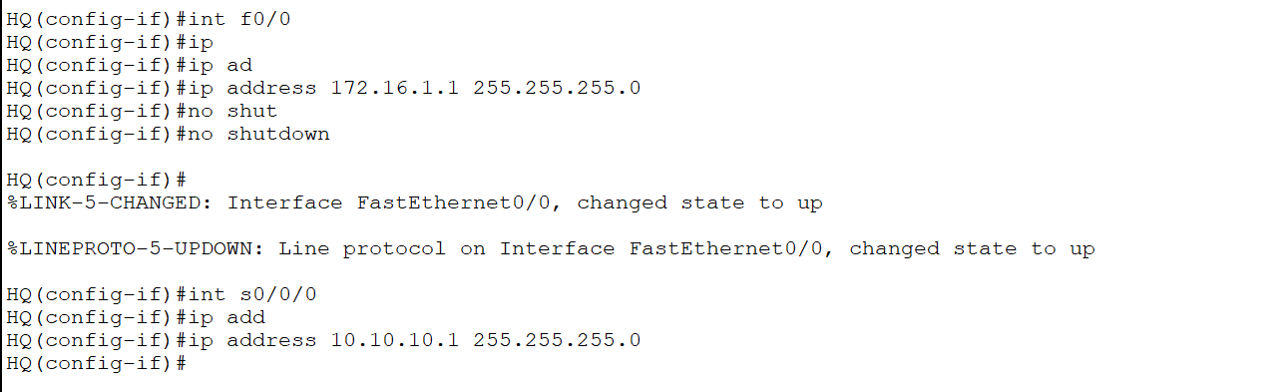
Router all traffic from the internet:-
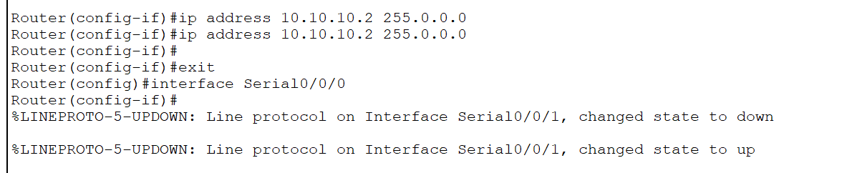
Route all traffic on the ISP for router1 as shown IP route 172.168.1.10 255.255.255.0 10.10.10.1 as well as for router 2 the ISP for router1 as shown IP route 192.168.1.10 255.255.255.0 11.11.11.1
In Router 1 route all traffic from internet to IP 10.10.10.2 i.e. IP route 0.0.0.0 0.0.0.0 10.10.10.2 whereas for Router 2 do IP routing to IP 11.11.11.2 i.e. IP route 0.0.0.0 0.0.0.0 11.11.11.2
On router 1 and Farm server router (router2)
- Configure ISAKMP policy to establish the Internet Key exchange tunnel
On router 1
Crypto isakmp enable
Crypto isakmp policy 20
Authenticate pre-share
Encryption 3des
Hash md5
Group 1
Lifetime 3600
Exit
Crypto isamkp key cisco123 address 11.11.11.1
- Define IPsec Transform set
Define IPsec Transform set (a combination of IPsec transforms designed to enact a specific policy for traffic.)
Crypto IPsec transform-set myset esp-3des esp-md5-hashmck
- Create access list
Access-list 100 permit IP 172.16.1.0 0.0.0.255 192.168.10.0 255.255.255.0
- Crete crypto map for IPsec
Crypto map mymap 20 IPsec-isakmp
Set peer 11.11.11.1
Set transform-set myset
Match address 100
Exit
- Apply the crypto map to the outgoing interface of the vpn device
Int s0/0/0
Crypto map mymap
- Testing and verifying vpn
From any pc under Router 1 ping the farm server
Verify commands
Show crypto isamp policy

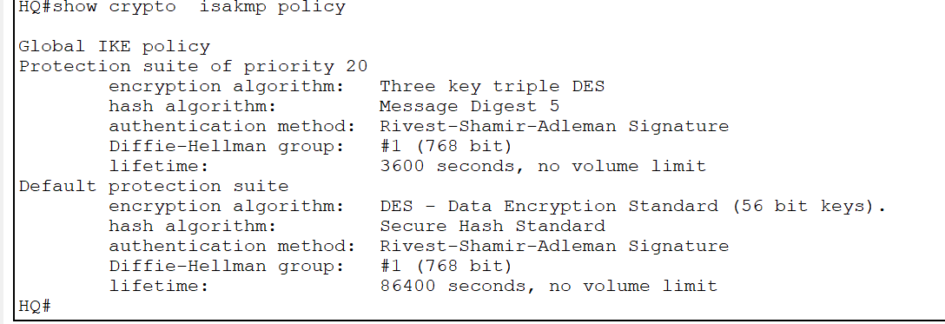

Show crypto map

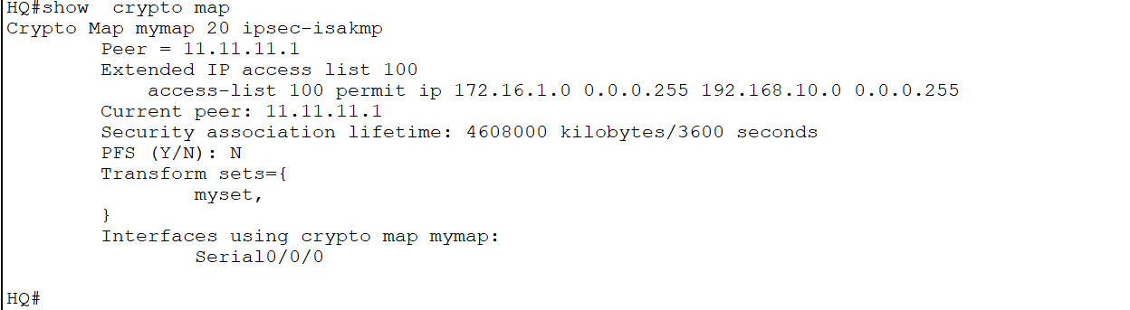

Show crypto IPsec sa

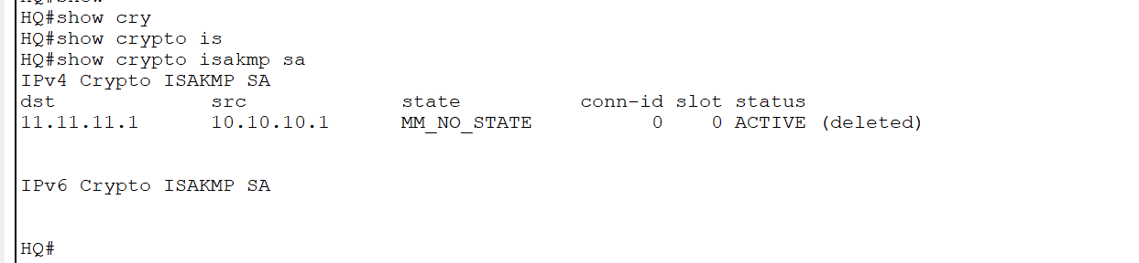

- Configure ISAKMP policy to establish the Internet Key exchange tunnel
On router 2
Crypto isakmp enable
Crypto isakmp policy 20
Authenticate pre-share
Encryption 3des
Hash md5
Group 1
Lifetime 3600
Exit
Crypto isamkp key cisco123 address 10.10.10.1
- Define IPsec Transform set
Define IPsec Transform set (a combination of IPsec transforms designed to enact a specific policy for traffic.)
Crypto IPsec transform-set myset esp-3des esp-md5-hashmck
- Create access list
Access-list 100 permit IP 192.168.10.0 0.0.0.255 172.16.1.0 255.255.255.0
- Crete crypto map for IPsec
Crypto map mymap 20 IPsec-isakmp
Set peer 10.10.10.1
Set transform-set myset
Match address 100
Exit
- Apply the crypto map to the outgoing interface of the vpn device
Int s0/0/0
Crypto map mymap
- Testing and verifying vpn
From any pc under Router 1 ping the farm server
Verify commands
Show crypto isamp policy

References
Banks, E., 2015. 4 Types of VPNs and When to Use Them. [Blog] Auvik.com, Available at: <https://www.auvik.com/franklymsp/blog/types-vpns/> [Accessed 14 May 2020].
Namecheap. n.d. How Does A VPN Work?. [online] Available at: <https://www.namecheap.com/vpn/how-does-vpn-virtual-private-network-work/> [Accessed 14 May 2020].
NordVPN. n.d. Nordvpn | What Is A VPN?. [online] Available at: <https://nordvpn.com/what-is-a-vpn/?gclid=CjwKCAjwte71BRBCEiwAU_V9h7kmwmnSIDhK1qY8WVywsypgtSRfQy4-GzojwAnlpxFFRTUg9fy6pxoC3UMQAvD_BwE> [Accessed 14 May 2020].
Ostif.org. 2017. The OpenvVPN 2.4.0 Audit By OSTIF And Quarkslab Results – Open Source Technology Improvement Fund. [online] Available at: <https://ostif.org/the-openvpn-2-4-0-audit-by-ostif-and-quarkslab-results/> [Accessed 14 May 2020].
Pixel Privacy. n.d. The Ultimate Guide To VPN Encryption - Pixel Privacy. [online] Available at: <https://pixelprivacy.com/resources/vpn-encryption/> [Accessed 14 May 2020].
Tech Differences. 2016. Difference Between Symmetric And Asymmetric Encryption (With Comparison Chart) - Tech Differences. [online] Available at: <https://techdifferences.com/difference-between-symmetric-and-asymmetric-encryption.html> [Accessed 14 May 2020].
VPNCop. 2018. Types Of VPN And 7 Types Of Protocols & More | Vpncop. [online] Available at: <https://vpncop.com/types-of-vpn/> [Accessed 14 May 2020].
Vpnoneclick.com. n.d. Types Of VPN And Types Of VPN Protocols - VPN One Click. [online] Available at: <https://www.vpnoneclick.com/types-of-vpn-and-types-of-vpn-protocols/> [Accessed 14 May 2020].
VPN University, 2016. How VPN Encryption Works | VPN University. [online] VPN University. Available at: <https://www.vpnuniversity.com/learn/how-vpn-encryption-works> [Accessed 14 May 2020].

